Session 2025-2026(EVEN)

Vision: Dream of where you want. | Mission: Means to achieve Vision

Program Educational Objectives of the program (PEO): (broad statements that describe the professional and career accomplishments)
PEO1 | Preparation | P: Preparation | Pep-CL abbreviation  pronounce as Pep-si-lL easy to recall
PEO2 | Core Competence | E: Environment (Learning Environment)
PEO3 | Breadth | P: Professionalism
PEO4 | Professionalism | C: Core Competence
PEO5 | Learning Environment | L: Breadth (Learning in diverse areas)

Program Outcomes (PO): (statements that describe what a student should be able to do and know by the end of a program)
Keywords of POs:
Engineering knowledge, Problem analysis, Design/development of solutions, Conduct Investigations of Complex Problems, Engineering Tool Usage, The Engineer and The World, Ethics, Individual and Collaborative Team work, Communication, Project Management and Finance, Life-Long Learning

PSO Keywords: Cutting edge technologies, Research

“I am an engineer, and I know how to apply engineering knowledge to investigate, analyse and design solutions to complex problems using tools for entire world following all ethics in a collaborative way with proper management skills throughout my life.” to contribute to the development of cutting-edge technologies and Research.

Integrity: I will adhere to the Laboratory Code of Conduct and ethics in its entirety.

Name and Signature of Student and Date
(Signature and Date in Handwritten)

Session | 2024-25 (EVEN) |  | Course Name | Java Full Stack Development Lab
Semester | 4 |  | Course Code | 23ADS1407
Roll No | 129 |  | Name of Student | Vidhi Chavhan
Practical Number |  | Practical 4
Course Outcome
Aim |  | WAP to implement Searching ( linear search ) and  Sorting (Bubble Sort ) in Java.
Problem Definition |  | The objective of this program is to implement searching using Linear Search and sorting using Bubble Sort in Java.  The program accepts a list of elements from the user and sorts them in ascending order using the Bubble Sort technique.  After sorting, Linear Search is applied to find a specified element in the list.  This program helps in understanding basic searching and sorting algorithms and their implementation using control structures and arrays in Java.
Theory  (100 words) |  | - Searching and sorting are basic operations used to manage data efficiently.  - Sorting arranges elements in a specific order, usually ascending or descending.  - Bubble Sort compares adjacent elements and swaps them if they are in the wrong order.  - The process repeats until the entire list is sorted.  - Bubble Sort is simple but less efficient for large datasets.  - Linear Search searches elements one by one in a list.  - It continues until the required element is found or the list ends.  - Linear Search is easy to implement and understand.  - These algorithms help in learning arrays, loops, and logic in Java.
Procedure and Execution  (100 Words) |  | Start the program and declare required variables and arrays in Java.  Accept the number of elements and input values from the user.  Apply Bubble Sort by comparing adjacent elements and swapping them when needed.  Repeat the sorting steps until the array is completely sorted.  Display the sorted array to the user.  Ask the user to enter the element to be searched.  Apply Linear Search to check each element sequentially.  If the element is found, display its position in the array.  If not found, display an appropriate message.  End the program after successful execution
Code:
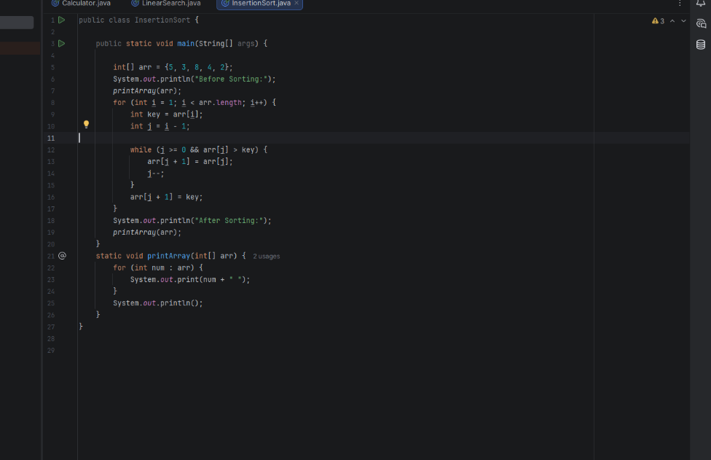

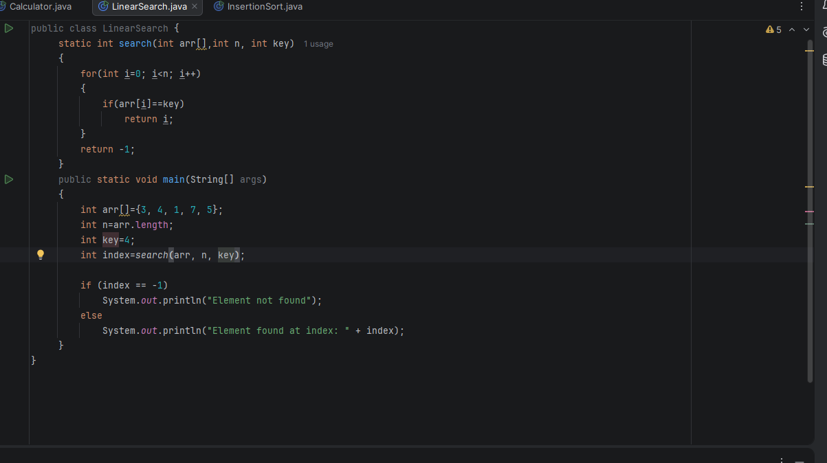
Output:
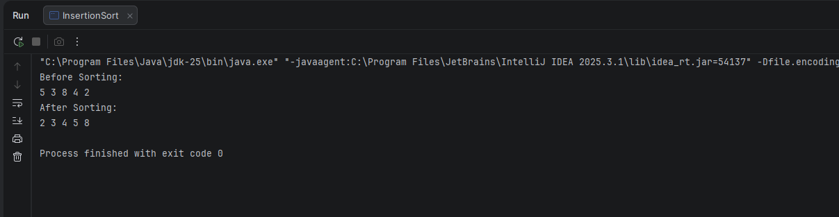
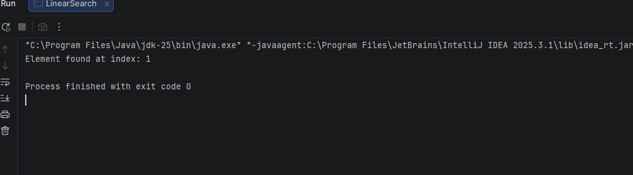
Output Analysis |  | - The program first displays the entered elements of the array.  - After applying Bubble Sort, the array is shown in sorted order.  - The sorting output confirms that elements are arranged correctly in ascending order.  - The user is prompted to enter an element to search.  - Linear Search checks each element one by one.  - If the element exists, its position in the array is displayed.  - If the element is not found, an appropriate message is shown.  - The output verifies the correct working of both sorting and searching algorithms.
Link of student Github profile where lab assignment has been uploaded |  | https://github.com/vidhichavhan18-cell/Java-Installation
Conclusion |  | This program successfully demonstrates the implementation of Bubble Sort and Linear Search in Java.  It helps in understanding basic searching and sorting techniques using arrays and loops.  The program improves logical thinking and forms a foundation for learning advanced algorithms.
Plag Report (Similarity index < 12%) |  | 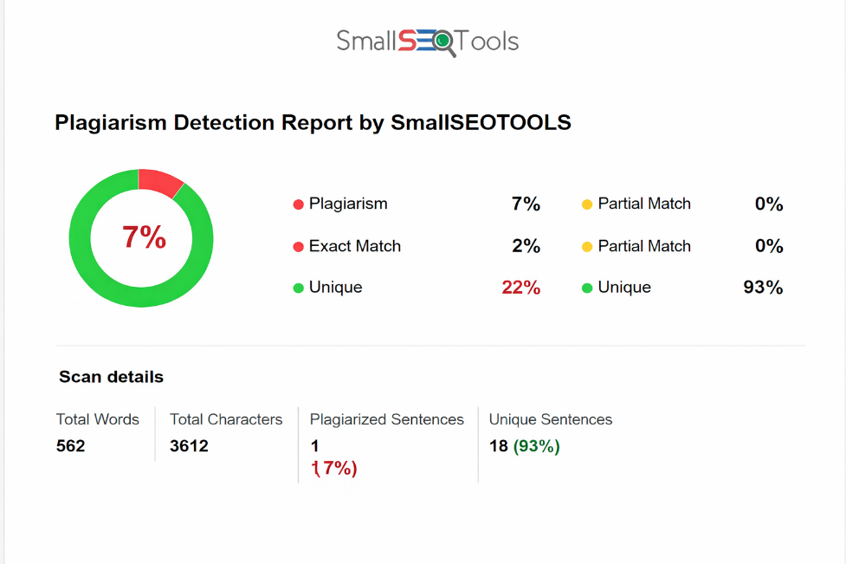
Date |  | 28.02.2026

Observation copy screenshot

